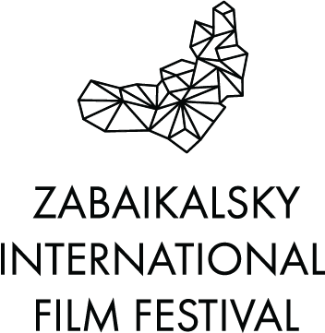

The announcement of the winners of the “Night of short meter”

On May 31, the winners of the short film competition were announced at the “Night of short meter” in Chita and the best works were shown.

This year, 478 requests were sent to the short film competition. The selection of the best films was carried out by a specialist in short films, a selector of federal channels, film expert Ruslan Abashin and program director of the film festival, film expert, candidate of art history, associate professor of VGIK. S.A. Gerasimova, head of film distribution at Nevafilm, film critic Maria Bezenkova.

The short list includes 7 films - they were shown on Dekabrists` Square in front of hundreds of viewers:

1. "We are the directors" dir. Sergey Ryzhkov
2. "Death of Taper" dir. Alexander Plotnikov
3. "Doctor" dir. Maxim Yusupov
4. "No" dir. Ivan Petukhov
5. "Flex" dir. Chingis Dormaev
6. "Goodbye, Amsterdam" dir. Natalya Shinelyova
7. "Lucky Ticket" (from the Non-Child Stories series) dir. Andrey Korf

The winners:

- In the nomination "For the Best Fiction Short" – film "Lucky Ticket" (from the Non-Child Stories series) dir. Andrey Korf
- In the nomination "For the Best Short Film Produced in Transbaikalia" - film "Doctor" dir. Maxim Yusupov.
- Diploma "For the education of new creative personnel of Transbaikalia" was given to the studio "Objective", SEI "Center for Social Education and Development" Open World ", Chita".
- In the nomination "For the best Documentary Short" the prize was not awarded.
The films were presented by Maria Bezenkova and film expert, editor responsible for the selection of short films for Russian TV channels Ruslan Abashin.
Screening of short films also visited: Elena Biryukova, Alexey Ogurtsov and Igor Ogurtsov, Marina Yakovleva, Dmitry Astrakhan, Andrey Rudensky, Aglaya Shilovskaya.

See more about festival: http://www.zmkf.ru/.

The organizer of the film festival is the Association of Initiative Citizens to Promote the Preservation and Development of the Ethnographic Culture of Siberia “Zabaikalskoe Zemlyachestvo” The festival is supported by the Governor, the Government and the Ministry of Culture of the Transbaikal Region.

The president of the film festival – people’s artist of Russia Alexander Mikhailov.

General sponsor of the film festival – Public Joint Stock Company «Mining and Metallurgical Company «Norilsk Nickel»

Lead Information Partner – Hearst Shkulev Group

Official sponsor of the film festival – «SUEK»

Official sponsor of the film festival – АО «ARMZ Uranium Holding »

Official carrier of the film festival – S7 AIRLINES

Sponsor of the film festival – Baikal Mining Company

Sponsor of the festival – a large network of supermarkets for children «Dochki & Sinochki»

