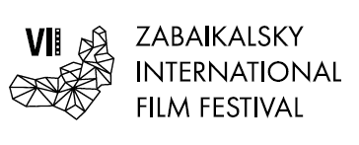
Moscow, April 23, 2018

Creative meeting with Andrey Merzlikin at the VII ZIFF

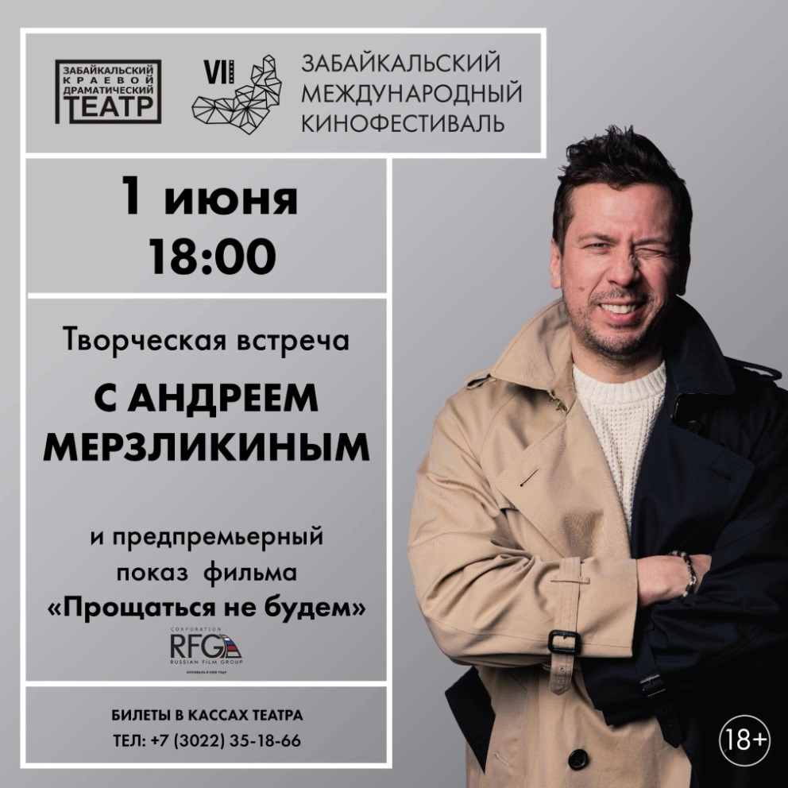

On June 1, in the Transbaikal Territory Drama Theater a creative meeting with the Russian theater and cinema actor, film director, TV presenter Andrei Merzlikin will be held. The actor will share his creative plans, talk about his theatrical premiere - the play "There Is Such a Guy", which is consisting of memories of outstanding writer and actor Vasily Shukshin.
In addition, Andrei Merzlikin will present the pre-premiere screening of the film "We will not say goodbye". Tthe official Russian premiere of this film will be held on June 21.

The action of the military-historical picture takes place in the late autumn of 1941, in the middle of the Moscow defensive operation. The audience will learn how a small town managed to stand against the enemy. Starring outstanding Russian actors : Andrei Merzlikin, Yegor Beroyev, Anna Churina, Ksenia Petrukhina and others.

Tickets for a creative meeting with Andrei Merzlikin can be purchased at the ticket offices of the Philharmonic.

The organizer of the film festival is the Association of Initiative Citizens to Promote the Preservation and Development of the Ethnographic Culture of Siberia "Zabaikalskoye Zemlyachestvo".

The film festival is held with the support of the Governor, the Government and the Ministry of Culture of the Transbaikalian Region.
General sponsor of the film festival - PJSC "GMK" Norilsk Nickel "
The leading sponsor of the film festival is ZAO InterMediaGroup
The sponsor of the film festival is "Siberian Coal Energy Company"
Partner of the festival is VTB Bank
Sponsor of the film festival - Baikal Mining Company
Sponsor of the film festival - supermarket chain "Daughters & Sons"
Official carrier of the film festival - S7 AIRLINES
Partners of the film festival:
- company "Group VIUR"
- Clinic "Asia Spa"
- house of fur and leather "Zimushka"

Leading television partner - TC "Altes" Leading Internet partner - 75.ru
Information partners of the film festival:
- Wday.ru portal - the project of Andrew Malakhov StarHit
- The newspaper "Transbaikalian worker"
- city portal "Chita now"
- radio "Siberia"

The president of the film festival is the People's Artist of the RSFSR Alexander Mikhailov.

Official site of the film festival - www.zmkf.ru

